**The Ark Documentation.**

**Pedigree.**

Once you have seen the confirmation message that the new subject has been created, you can proceed to add pedigree information.

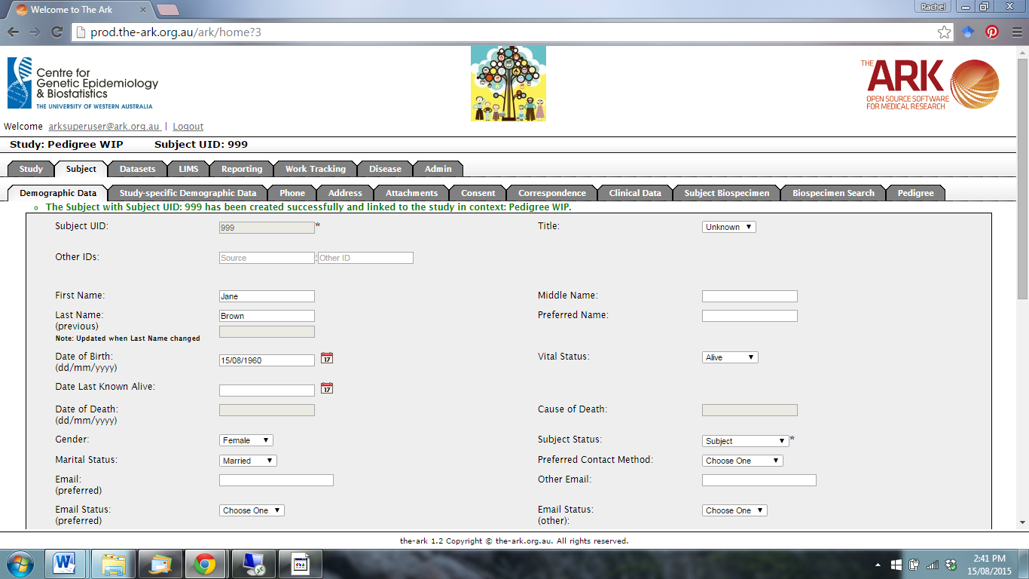

Click on the Pedigree function.

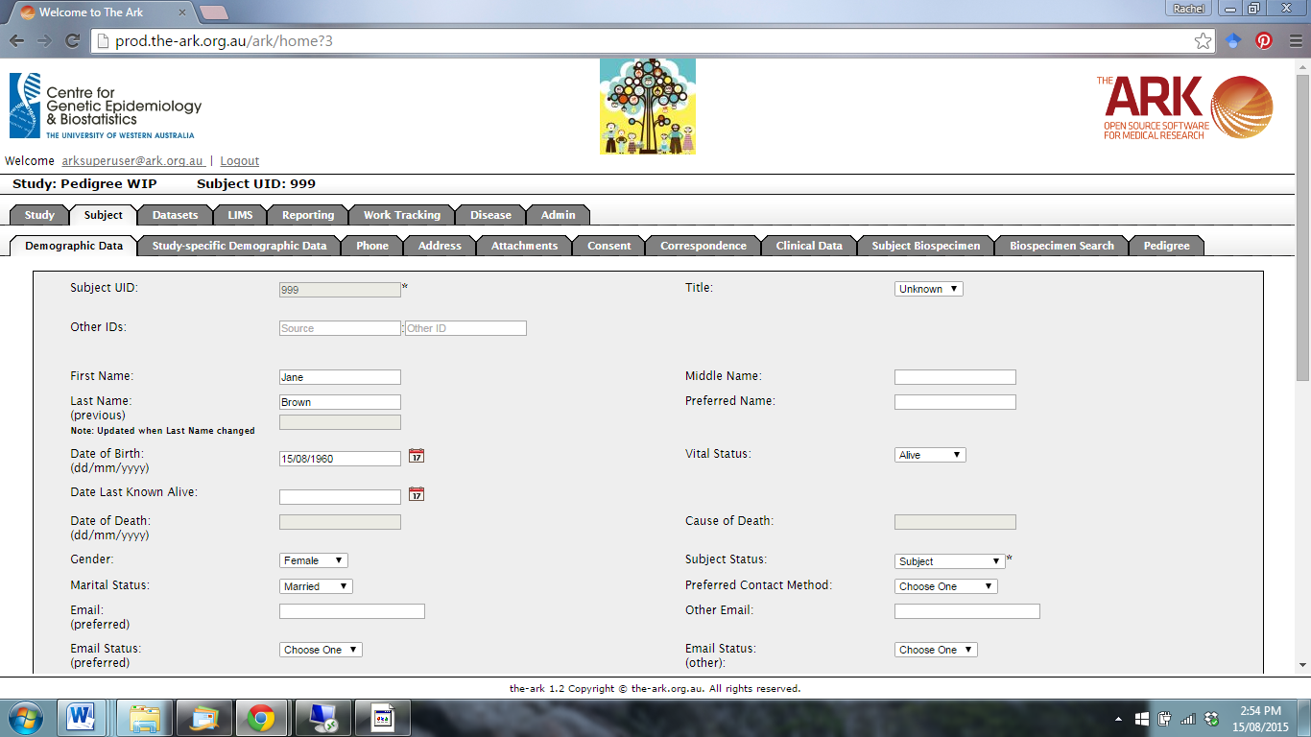

The following page will appear.

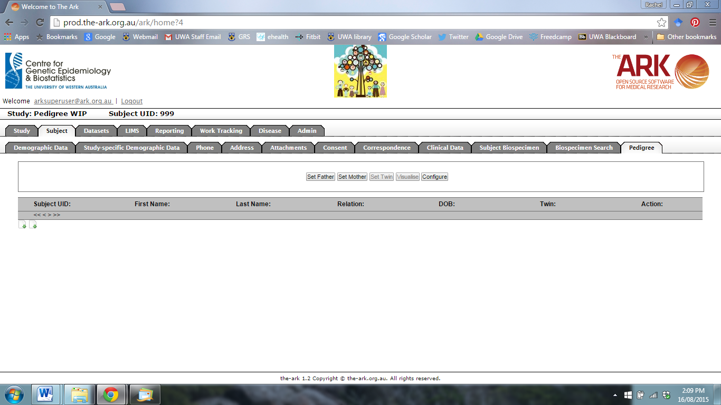

To link the current subject to their father, click on the Set Father function.

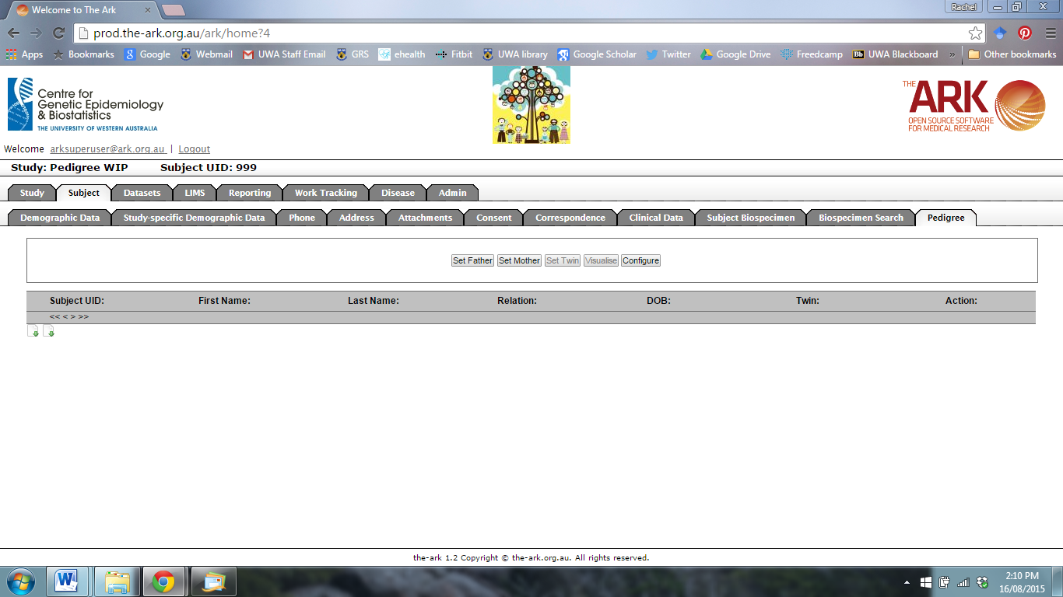

The following page will appear.

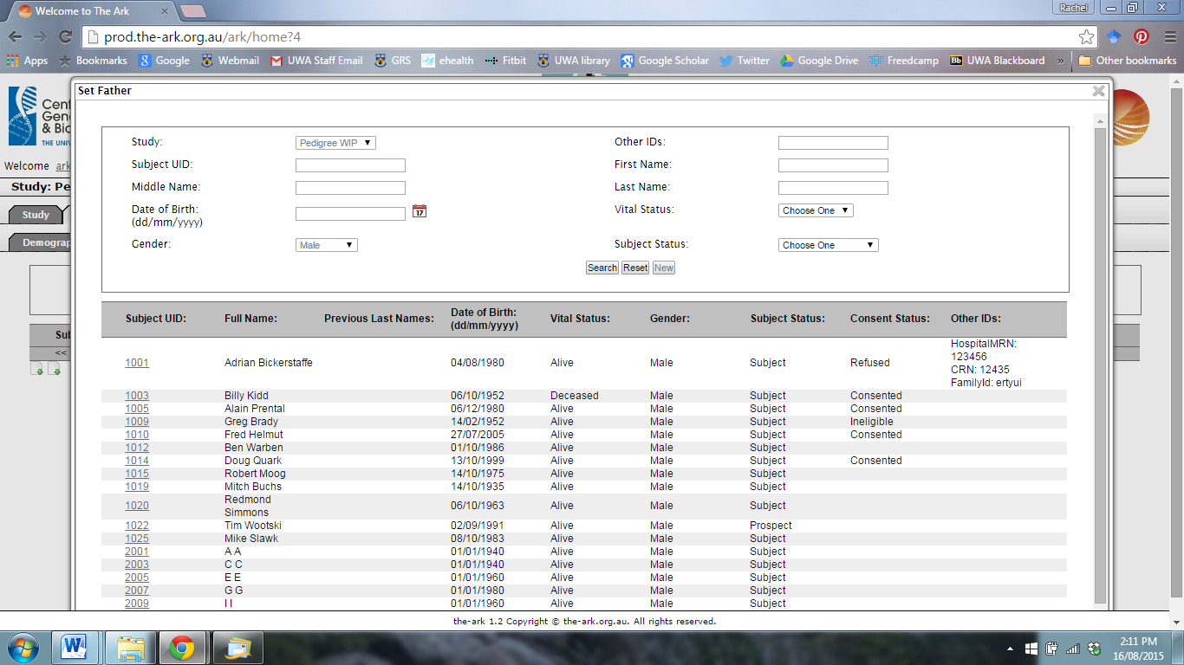

You can either search for an existing subject entry in the database (Search), or create a new entry (New).

.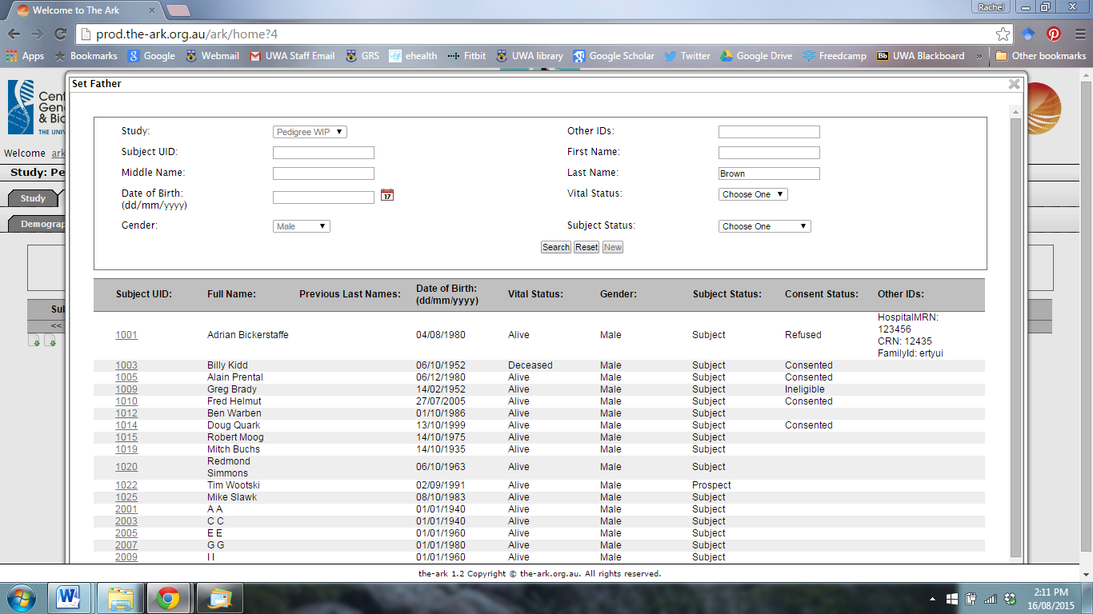

Repeat the instructions to link the current subject to their mother.

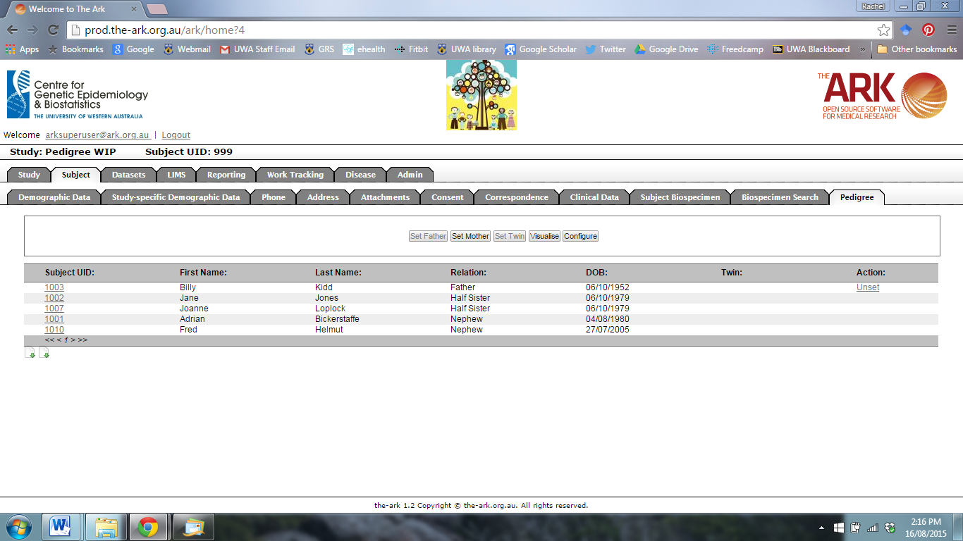

You can click the Visualise function to see a pedigree.



The following page will appear.

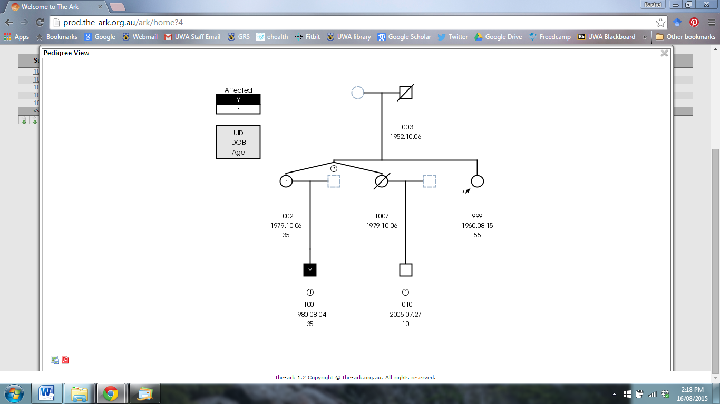

To configure the pedigree, click the Configure function.

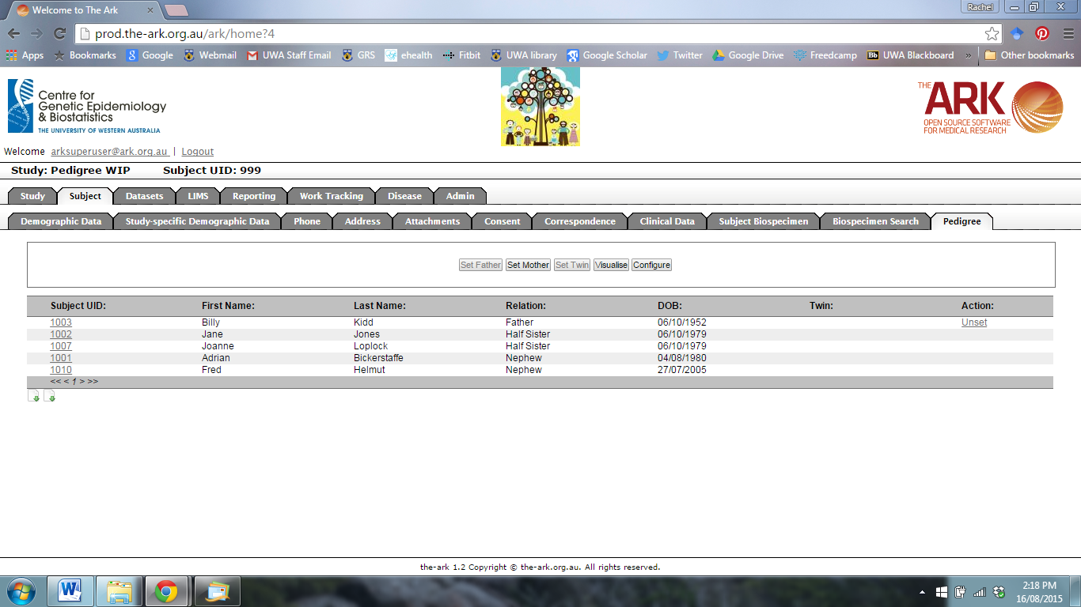

The following page will appear.

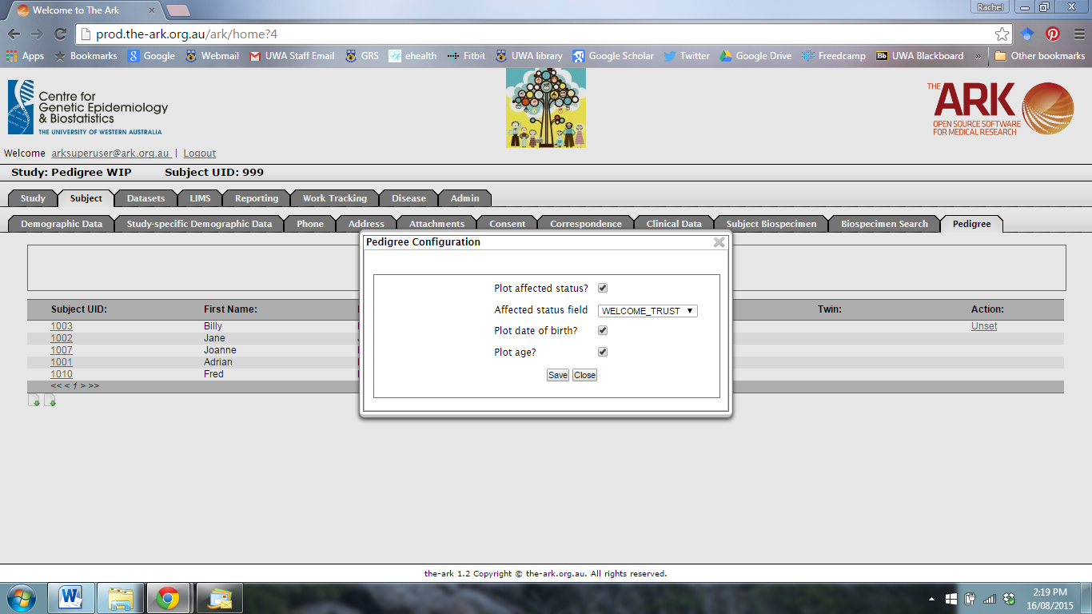

Click save and exit to return to the Pedigree function.